CREATE FUNCTION cal_gross_sal(

basic_salary IN NUMBER

) RETURN NUMBER

IS

da_percentage CONSTANT NUMBER := 0.4;

hra_percentage CONSTANT NUMBER := 0.2;

pf_percentage CONSTANT NUMBER := 0.12;

gross_salary NUMBER;

BEGIN

gross_salary := basic_salary + (basic_salary * da_percentage) + (basic_salary * hra_percentage) -

(basic_salary * pf_percentage);

RETURN gross_salary;

END cal_gross_sal;

/

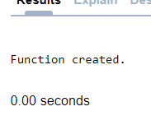

DECLARE

basic_salary NUMBER;

gross_salary NUMBER;

BEGIN

basic_salary := :basic_salary;

gross_salary := cal_gross_sal(basic_salary);

DBMS_OUTPUT.PUT_LINE('Gross Salary: '|| gross_salary);

END;

/

